***TastySnaps***

**Test Strategy**

**Revision History**

| Date | Version | Author | Description |
| --- | --- | --- | --- |
| 26/05/2024 | 1.0 | Petrenko Victoria | Basic Version |
|  |  |  |  |
|  |  |  |  |
|  |  |  |  |

**Table of Contents**

**1. Scope** **3**

**2. Test Approach 5**

**3. Test Environment 9**

**4. Testing Tools 10**

**5. Release Control 11**

**6. Risk Analysis 12**

**7. Review and Approvals 14**

# Scope

Stakeholders want to develop the TastySnaps project to create an innovative and engaging mobile platform that allows users to share food photos, interact through comments and likes, make new friends by interests and discover new culinary ideas.

This will help quickly understand user needs, prioritise functionality, and ensure a competitive edge in the growing market of food photo-sharing applications.

The Test Strategy document will be reviewed by key stakeholders. The following roles are responsible for reviewing this document:

| **Role** | **Name** | **Signature** | **Date** |
| --- | --- | --- | --- |
| Scrum Master | [Scrum Master's Name] |  | [Date] |
| QA Test Lead | [QA Test Lead's Name] |  | [Date] |
| iOS Developer Lead | [iOS Developer's Name] |  | [Date] |
| Android Developer Lead | [Android Developer's Name] |  | [Date] |
| Back-End Developer Lead | [Back-End Developer's Name] |  | [Date] |
| UX/UI Designer Lead | [UX/UI Designer's Name] |  | [Date] |
| Database Administrator | [Database Admin's Name] |  | [Date] |
| Product Owner | [Product Owner's Name] |  | [Date] |
| Stakeholder Representative | [Stakeholder's Name] |  | [Date] |

The Test Strategy document must be approved by the following roles before the testing activities commence:

* Product Owner: [Name]
* QA Test Lead: [Name]
* Scrum Master: [Name]

The testing activities for the TastySnaps application are divided into several phases:

1. Test Planning

Start Date: Week 1

End Date: Week 2

1. Test Environment Setup

Start Date: Week 2

End Date: Week 3

1. Test Case Development

Start Date: Week 2

End Date: Week 4

1. Functional Testing

Start Date: Week 5

End Date: Week 8

1. Non-Functional Testing

Start Date: Week 6

End Date: Week 7

1. Regression Testing

Start Date: Week 7

End Date: Week 8

1. User Acceptance Testing (UAT)

Start Date: Week 8

End Date: Week 9

1. Test Closure

Start Date: Week 9

End Date: Week 10

# Test Approach

It defines

* **Process of testing**

The testing approach involves manual testing techniques to ensure comprehensive coverage of the core application's functionalities, focusing on user interactions. QA will be preparing test cases based on the exploratory testing. This will cover all scenarios for requirements.

Test cases are executed on multiple Android and iOS devices to ensure compatibility.

QA conducts manual performance testing to identify bottlenecks and optimise performance.

Developer team will execute automated test scripts that run on the developer environment.

* **Testing levels**
* Component testing or Unit testing
* Integration testing
* System testing
* Acceptance testing
* **Roles and responsibilities of each team member**

Personnel:

* Scrum master
* 3 developers: back-end, iOS, Android
* QA Test Lead
* QA Testers
* UX/UI Designers
* Database Administrator

**Scrum Master Responsibilities**:

1. Facilitate daily stand-ups, sprint planning, sprint reviews, and retrospectives.
2. Ensure the team adheres to Agile principles and Scrum practices.
3. Remove any impediments that may hinder the team's progress.
4. Act as a communicator between the development team and stakeholders.
5. Track and report on project progress and team performance.

***Developers:***

**Back-End Developer Responsibilities**:

1. Design, develop, and maintain the server-side logic.
2. Implement APIs and integrate with front-end services.
3. Optimise the application for performance and scalability.
4. Collaborate with QA to resolve backend-related defects.

**iOS Developer Responsibilities:**

1. Design, develop, and maintain the *TastySnaps* iOS application.
2. Ensure the application meets performance and quality standards.
3. Implement new features and fix iOS-specific issues.
4. Collaborate with UX/UI designers to ensure a seamless user experience.

**Android Developer Responsibilities:**

1. Design, develop, and maintain the *TastySnaps* Android application.
2. Ensure the application meets performance and quality standards.
3. Implement new features and fix Android-specific issues.
4. Collaborate with UX/UI designers to ensure a seamless user experience.

**QA Test Lead Responsibilities:**

Oversee the overall testing process and strategy.

Coordinate and manage the QA team, ensuring test activities align with project goals.

Review and approve test plans, test cases, and test scripts.

Ensure defects are documented, tracked, and resolved promptly.

Communicate test progress, results, and issues to stakeholders.

**QA Testers Responsibilities:**

Design and execute test cases based on functional and non-functional requirements.

Perform manual testing to identify defects and ensure quality.

Document test results and report defects in the tracking system.

Conduct retesting and regression testing after defect fixes to ensure stability.

Collaborate with developers to reproduce and resolve defects.

**UX/UI Designers Responsibilities:**

Design intuitive and visually appealing user interfaces for the *TastySnaps* application.

Conduct user research and usability testing to gather feedback and improve the design.

Create prototypes, and mockups to communicate design ideas.

Ensure consistency in the design across iOS and Android platforms.

Collaborate with developers to ensure design feasibility and implementation.

**Database Administrator Responsibilities:**

Design, implement, and maintain the database schema and structure.

Ensure data integrity, security, and performance optimization.

Perform regular backups and recovery operations.

Monitor database performance and make necessary adjustments.

Support the development and QA teams with database-related tasks and issues.

* **Types of Testing**

Functional (installation, authorization, features)

Non-functional (performance, localization, security, UI/UX, compatibility, compliance to regulations and standards)

* **Testing approach & automation tool if applicable**

The testing approach involves manual testing techniques to ensure comprehensive coverage of the core application's functionalities, focusing on user interactions. QA will be preparing test cases based on the exploratory testing. This will cover all scenarios for requirements.

Test cases are executed on multiple Android and iOS devices to ensure compatibility.

QA conducts manual performance testing to identify bottlenecks and optimise performance.

Developer team will execute automated test scripts that run on the developer environment.

* Testing levels:

Unit Testing.

Integration Testing.

System Testing.

Acceptance Testing.

* Adding new defects, re-testing, Defect triage, Regression Testing and test sign off

**Adding New Defects:**

Testers will document any new defects discovered during the testing process using a Jira tracking system. Each defect will be described, including steps to reproduce and any relevant attachments.

**Re-testing:**

Testers will provide re-testing to verify that the fixes have been implemented correctly and that no new defects appeared.

**Defect Triage:**

The QA team will prioritise defects based on severity and priority, ensuring that critical issues are documented and redirected to the developers or designers.

**Regression Testing:**

Regression testing will be performed after significant changes to ensure that existing functionality remains unaffected.

**Test Sign Off:**

Before the application is released for production, the QA team will conduct a final review of all testing activities and deliverables. The QA Lead will provide formal sign-off indicating that the application meets the defined requirements, quality standards and is ready for deployment.

# Test Environment

***Mobile Devices:***

A variety of iOS and Android devices (phones and tablets) to cover different OS versions and screen resolutions.

Minimum: 5 Android devices, 5 iOS devices.

***Network:***

Stable internet connections to simulate real-world usage conditions.

Tools to simulate different network conditions

***Backup Strategy:***

Automated backups of test data will be scheduled at regular intervals (twice a day).

***Restore Strategy:***

In the event of data loss or corruption, the latest backup will be restored.

Restoration procedures will be tested to ensure recovery of test data.

# Testing Tools

Test management tools (Jira, TestRail) for tracking test cases and defects.

Performance testing tools.

Security testing tools.

*Communication Tools:*

Collaboration tools (Slack) for team communication.

Documentation tools (Google Docs) for maintaining test documentation.

# Release Control

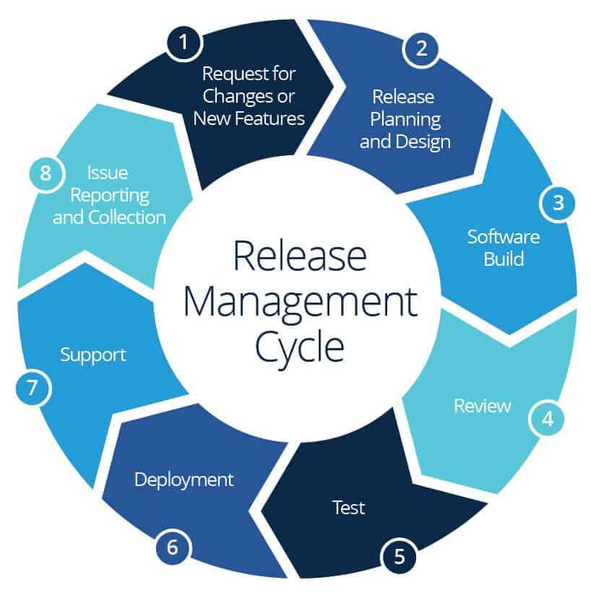

The testing will ensure systematic control over software releases.

# Risk Analysis

**Potential risks associated with the software.**

*Product risks:*

1. Functionality gaps: certain features may not be implemented as required, leading to functionality gaps.
2. Performance issues: during peak usage time the application may suffer from performance issues, influencing user experience.
3. Security vulnerabilities: a risk of security breaches and other common vulnerabilities.
4. Compatibility problems: the application may not function correctly on all targeted devices and operating systems.

*Team risks:*

1. Skill gaps: the development team may lack specific skills for implementing certain features.
2. Communication failure: problems of communication between team members and stakeholders may result in misunderstanding of requirements, goals and wrong decisions.
3. Resource restrictions: limitations may impact the project timeline and quality.

*Business risks:*

1. Market competition: the market of photo-sharing applications is overfilled with established players, thus attracting a significant amount of users may become a problem.
2. Profit generation: monetization may be challenging, it requires implementation of advertisement and premium features.

**Potential planning risks:**

1. Schedule delays: testing activities may take longer than expected, leading to delays in the project timeline.

Contingency: implement a buffer period in the schedule to cover potential delays. Prioritise critical and high test cases to ensure essential functionality is tested first.

2. Resource availability: personnel may be unavailable due to unforeseen circumstances such as illness, blackouts or personal emergencies.

Contingency: train team members to cover critical roles. Maintain a pool of part-time or contract testers who can be involved if needed.

1. Problems with test environment: may not perform as expected.

Contingency: review and update the test environment to ensure it is adequate to the production setup.

1. Changing Requirements:

Risk: Requirements may change during the testing phase, leading to additional testing efforts.

Contingency: Maintain flexibility in the test plan and update test cases as requirements evolve. Regularly communicate with stakeholders to manage changes

# Review and Approvals

* All these activities are reviewed and sign off:

| **Role** | **Name** | **Signature** | **Date** |
| --- | --- | --- | --- |
| Scrum Master | [Scrum Master's Name] |  | [Date] |
| QA Test Lead | [QA Test Lead's Name] |  | [Date] |
| iOS Developer Lead | [iOS Developer's Name] |  | [Date] |
| Android Developer Lead | [Android Developer's Name] |  | [Date] |
| Back-End Developer Lead | [Back-End Developer's Name] |  | [Date] |
| UX/UI Designer Lead | [UX/UI Designer's Name] |  | [Date] |
| Database Administrator | [Database Admin's Name] |  | [Date] |
| Product Owner | [Product Owner's Name] |  | [Date] |
| Stakeholder Representative | [Stakeholder's Name] |  | [Date] |

* Summary of review changes should be traced at the beginning of the document along with approved date, name, and comment.